

PZero: Developer Test

# Conditions of the assessment

Under none of the sections will you be allowed to receive assistance from any other person.

# Time limit

Assessment is to be returned no later than 2 days after receipt. Late submission will be an automatic fail.

## Section 1

* Internet **may not** be used to solve the questions.
* Your computer may not be used to help you solve these questions.
* You may use no reference material or notes to solve these questions.

## Section 2

* Internet **may** be used in this section.
* We will be testing ability to problem solve and learn new skills.

## Section 3 (bonus points)

* Internet **may** be used.
* This will be to test ability to learn new frameworks.

# Section 1

1. You are given a series 1,2,3 … recognize the pattern and write a small piece of php code to print out this series up until *infinity (infinite loop).*

$f1 = 0;

$f2 = 1;

$n = 30;

While (true) {

$f3 = $f1 + $f2;

      $f1 = $f2;

$f2 = $f3;

echo $f3 . ", ";

}

1. *You are given a series 1,3,6,10 … recognize the pattern and write a small piece of php code to print out this series up until infinity (infinite loop).*

$start = 1;

   $startCounter = 2;

   echo $start . ', ';

   while (true) {

    $sum = $start + $startCounter;

      echo $sum . ', ';

      $start = $sum;

      $startCounter++;

   }

1. Explain what it means to define a class as abstract:

An abstract class is a class with at least 1 abstract method. All methods in an abstract class are defined ONLY and the methods body is to be coded /implemented in the class that extends the abstract class. Abstract classes are defined with the “abstract” keyword.

1. Briefly explain the difference between private and protected in terms of OOP:

Private means that the property or method can only be accessed within the class.  
Protected means that the property or method can be accessed in the class itself, as well as by classes that extend.

1. Define the following php functions:

* explode

Break a string into an array based on a character or string of characters.

* stripos

Finds the position of the first occurrence of a string with in another string.

* rtrim

Removes characters from the right side of a string that are placed in the 2nd parameter of the rtrim function.

* require

The require statement includes and evaluates a specified file, and if the statement fails, a E_COMPILE_ERROR is produced.

* require_once

A statement that tells PHP to include a file or data but if the file or data has already been included then PHP will not include it again.

 6. What would the following code output:

for ($i = 0; $i < 5; $i++) {

echo $i;

continue;

}

Answer : 01234

     7. What would the following code output:

do {

echo “1”;

continue;

echo “2”;

break;

} while (false);

Answer : 1

8. You are given 2 tables in a database, a user table and a company table.

|  |
| --- |
| **User** |
| id |
| username |
| company_id |

|  |
| --- |
| **Company** |
| id |
| name |

Write a query to give the following result :

|  |  |
| --- | --- |
| **user_name** | **company_name** |
| Pete | Pzero |

[SELECT](http://localhost/phpmyadmin/url.php?url=https://dev.mysql.com/doc/refman/8.0/en/select.html) u.username as user_name, c.name as company_name from users u, company c WHERE u.company_id = c.id;

10. Briefly describe what JSON is and what php functions you would use to make use of JSON on a day to day basis:

* 1. JSON stands for Javascript Object Notation and it is a lightweight data-interchange format.
  2. I use the 2 functions json_encede() and json_decode()

# Section 2

In this section you will be scraping data and putting it into a usable format for further development. With php code read the following web page.

<https://www.worldometers.info/coronavirus/>

Parse and read this table of data.

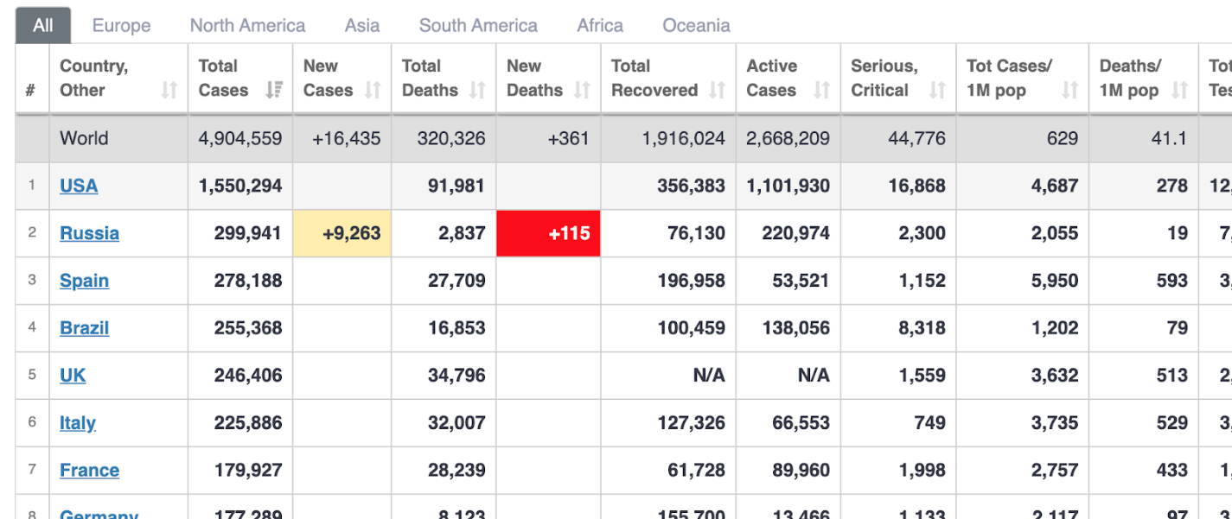

Then format that data into a json string with the following fields.

*Country, total cases, new cases, total deaths, new deaths and total recovered.*

You can structure your json as you like as long as it follows a logical structure and conforms to json standards as you will be needing it in the next section.

Commit your php code either to bitbucket or github and share the link of your code repository to earn credit for this question.

# Section 3 (bonus points)

In this section we will be testing your ability to learn new skills and adapt to be able to take on new challenging projects with new technologies. Create a new laravel project with user authentication using the standard laravel auth feature. Create a basic admin section which reads the json data you created in section 2 and displays it in a table format in your admin section. Be sure to include all your migrations in your code base so that we can create this project by running migrations. Also please make use of a MySql database to store your user credentials. Your data table in the admin section must read from your json file created in section 2 and not from the database.

Commit all your code to bitbucket or github and share the repository url with us.